

**NW1000™ Data Sheet**

revision 0.2

**1) Device description:**

The NW1000™ radio module is a highly integrated, cost-effective, Smart Radio, sub-1 GHz wireless node solution composed of a transceiver which uses DBPSK modulation, with a low-power ARM® Cortex M3 CPU.

The highly integrated RF transceiver operates on a wide range of frequency, including: 315MHz, 433MHz, 470MHz, 868MHz, 915MHz in the license-free Industrial, Scientific & Medical (ISM) frequency bands.

This configuration allows users to minimize the use of external components.

|  |  |  |
| --- | --- | --- |
| |  | | --- | | **Key benefits:**  • Best radio modem for smart metering.  • 10 miles in harsh city environment.  • 20 years on AA battery.  • NWave™proprietary radio protocol.  • FCC compliant.  • UNB resulting in small antennas.  • Low power without sacrificing link budget.  • Ultra low power wake‐on‐radio mode.  • Option to embed user’s firmware into modules MCU.  • Data rate: 100bps via NWave™ proprietary protocol.  **Applications:**  • Automated Meter Reading.  • Wireless Sensor Networks.  • Home and Building Automation.  • Wireless Alarm and Security Systems.  • Industrial Monitoring and Control. |   **Host interface:**  • Absolute maximum voltage on I/O pin: +4V.  **Interface is not 5V tolerant.**  • 10 General Purpose I/O pins.  • Configurable: Push ­ Pull, Open Drain,  Pull‐ up/Pull-down, input filter, drive strength.  • Pin Interrupt.  • Output state retention & Wake‐up  from Shut‐down Mode.  • LVTTL (+3.3V logic) simple Low energy UART interface.  • AT commands are used to communicate between host and  NWRM1000 module. | **General parameters:**  • Surface mount, 22x16x4mm, land grid array (LGA)  packaging.  • Operating temperature range:  between ‐40 degree C to +85 degree C  • Single supply voltage: +3.3V to +3.8V.  **Radio interface parameters:**  • Output power range: **‐10dBm to 16dBm**.  • Output power regulation in **0.5dB** steps.  • Adjacent channel power: **‐50dBc**.  • Wireless M‐Bus support.  • Customer configure power output.  • Customer configured frequency.  • Customer configured working channel.  **Power consumption:**  • During broadcast: **22mA @ 10dBm**  or **54mA @ 15dBm**.  • Sleep mode with RAM retention and  wake‐up timer running at **1.5 µA**.  **Built-in microcontroller:**  • ARM Cortex‐M3, 32‐bit CPU platform.  • Wake‐up Interrupt Controller.  • 32.768 kHz Crystal Oscillator.  **Programming/debugging interface:**  • 2 wire Serial Debug Interface.  **Device memory size:**  • Total size of Flash: 128kB.  • Total size of RAM: 16kB.  • Memory occupied by NWave firmware: ??kB  • Memory available for customer application: ??kB |

**2) Host - module interface description:**

The NW1000 communicates with the host MCU over a UART interface RX, TX pins.

Host MCU can use set of AT commands to set the carrier frequency of NW1000 & send data to the NWave Network.

The serial interface is designed to operate using serial protocol parameters:

**LVTTL (+3.3V logic), 9600 bps, 8 data bits, 1 stop bit, no parity**.

**3) NW1000™ Functional Block Diagram**

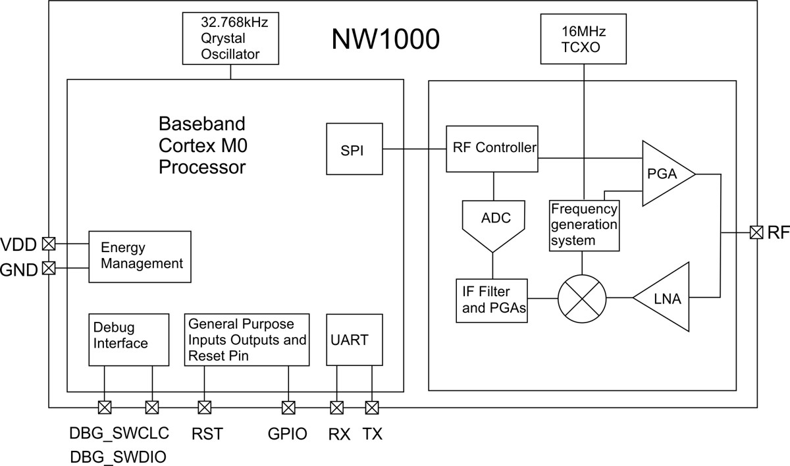

**4) NW1000™ Pin-out:**

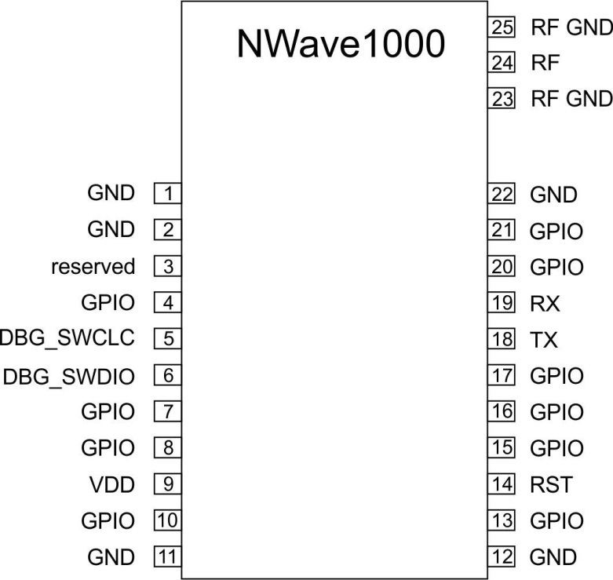

**5) NW1000™ Pin-out description:**

|  |  |  |  |
| --- | --- | --- | --- |
| **Pin #:** | **Symbol:** | **Description:** | **Available alternate functions:** |
| **1** | **GND** | Ground |  |
| **2** | **GND** | Ground |  |
| **3** | reserved | Do not connect |  |
| **4** | **GPIO** | I/O port | ACMP1C6 - analog comparator 1 input 6 |
| **5** | **DBG_SWCLC** | Debug interface, clock line |  |
| **6** | **DBG_SWDIO** | Debug interface, data line |  |
| **7** | **GPIO** | I/O port | SDA - I2C data line / Timer 0 Capture Compare Input 0 |
| **8** | **GPIO** | I/O port | SCL - I2C clock line / Timer 0 Capture Compare Input 1 / Clock Management Unit, clock output 1 |
| **9** | **VDD** | +3.3V power supply input |  |
| **10** | **GPIO** | I/O port | ADC0 - ADC input 0 / PCNT0 - Pulse Counter input 0 |
| **11** | **GND** | Ground |  |
| **12** | **GND** | Ground |  |
| **13** | **GPIO** | I/O port | ADC1 - ADC input 1 / PCNT1 - Pulse Counter input 1 |
| **14** | **RST** | Reset input, active low |  |
| **15** | **GPIO** | I/O port | DAC0 - DAC output / LETIM0 - output channel 0 |
| **16** | **GPIO** | I/O port |  |
| **17** | **GPIO** | I/O port | ACMP1C7 - analog comparator 1 input 7 |
| **18** | **Tx** | Low Energy UART0 output |  |
| **19** | **Rx** | Low Energy UART0 input |  |
| **20** | **GPIO** | I/O port | ADC0 - ADC input 6 / LETIM0 - output channel 0 |
| **21** | **GPIO** | I/O port | ADC0 - ADC input 7 / LETIM0 - output channel 1 |
| **22** | **GND** | Ground |  |
| **23** | **RF GND** | RF Ground |  |
| **24** | **RF** | Aerial (Antenna) connection pin |  |
| **25** | **RF GND** | RF Ground |  |

**6) Mechanical dimension & PCB pads layout:**

All dimensions in millimeters.

Top side view.

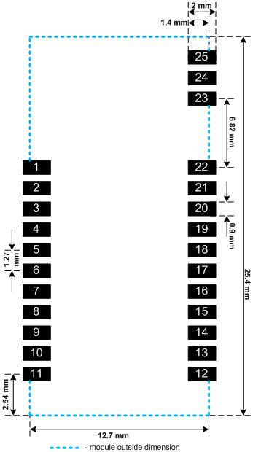

**7) List of available AT commands for host - module communication:**